**Advertising in New York**

Coty Marchlewski

April 28, 2019

**1. Introduction**

**1.1 Background**

New York City is a very popular and great cultural destination for any tourist. An advertising company in New York City is having trouble deciding what to advertise to tourists and vacationers. With many historic landmarks and a bountiful amount of entertainment available to people it is hard to determine what people would truly be interested in visiting.

**1.2 Problem**

With all the available locations to visit which are the most popular and are most likely to make people recommend and keep visiting New York City. With this project I intend to give the company a good idea of what 10 locations would be best for them to advertise.

**1.3 Interest**

Obviously the company itself would be interested in this and also the tourists and vacationers to the city would also be. Another group this would benefit would be the city itself and all of the destinations involved.

**2. Data Acquisition and Cleansing**

**2.1 Data Sources**

I was unable to use the Foursquare tool for any data collection so instead I was forced to rely on other methods to gather my data for this project. I focused on areas that were relatively close to each other and also based on reviews made by people who have visited these sites themselves.

**2.2 Data Cleansing**

I looked at multiple locations that are in New York City and gathered data on them into one table I created. Some of the problems that I ran into were that some locations required reservations and others required a means of transportation to reach them.

For the bulk of my cleansing, I decided to remove any location that needed reservations and kept any location that did require you to travel to it by some means of transportation. The main location that required transportation to reach was the Statue of Liberty but I was not willing to exclude that one due to its importance to our culture and the message for which it stands.

**2.3 Feature Selection**

I decided to mainly focus on locations that had a rating of 4.6 and above. I decided to leave out number of people who visit per year and cost of each location because of the limited amount of information that was available to me.

**3. Exploratory Data Analysis**

**3.1 Finding my Results**

I went through multiple sites and resources to determine what the best locations to advertise would be and compared and contrasted each site based on what they had to offer. After much debating with myself I picked 10 locations that seemed to me would offer both the best entertainment to people touring New York City, the best cultural experience, and the best historical lessons for people who were touring and vacationing in New York City.

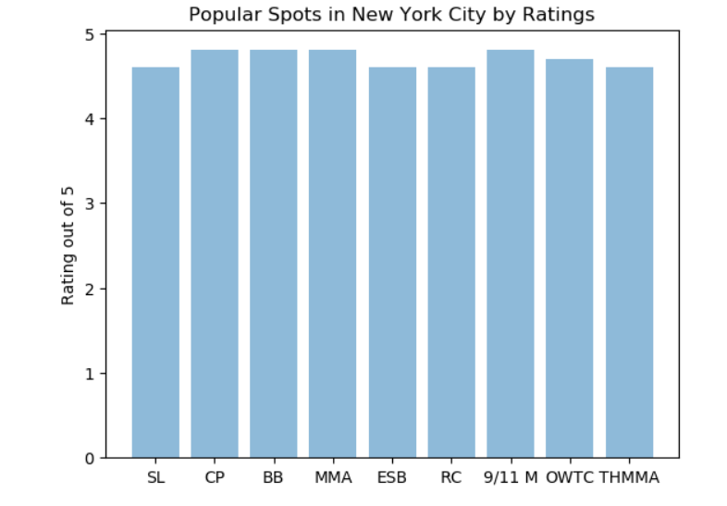Here are the Results that I came up with.

**4. Conclusions**

With this project I have learned various things about Data Science that have proven to be very useful and this project hopefully is a demonstration of that. Based on what I have gathered from my data the advertising company should advertise Central Park, Brooklyn Bridge, The Metropolitan Museum of Art, the 9/11 Memorial, and the One World Trade Center. Based on my findings with the data I used these were some of the best rated locations in New York City and each has both very significant historic and cultural things offer to tourists and vacationers.

**5. Future Advertising**

I would recommend that the advertising company keep up with trends of what is going on in the area in order to be up-to-date with what people want. I would also recommend that the company start asking for feedback from people about what their favorite sites and attractions are in New York City.